HOW TO CONFIRM YOUR MEAL CHOICES IN BASKET
As the system requires you to have enough balance in your Meals account to cover the cost of your current and future meal choices, your choices are added to your Basket before being fully confirmed.
You can identify which choices are unconfirmed by looking for the words "In basket" and by referring to the warning banner at the top of the page, alerting you that there are Meal choices in basket.
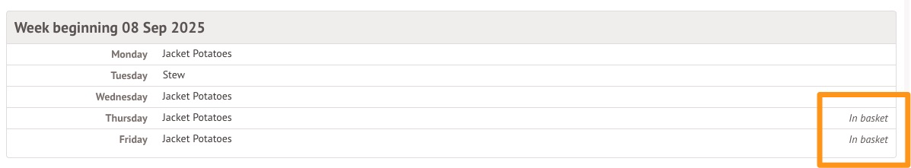
Click on the Go to your basket link in the banner or head to My Items > My Payments using the menu to view your pending choices.
If your balance is sufficient, the amount will be £0.00 and the banner will say: ‘The amount on your account is sufficient to cover your meal choices. Please complete Checkout to complete your order.’ By clicking Checkout confirms your selections instantly.
If your balance is insufficient for the amount of meals you are trying to order, you'll need to enter your card details to pay the difference before confirming your choices. The banner will say ‘Top up your account by (required amount) or remove meals from basket’. You can then process payment or go back to your meals in the menu and remove meals by clicking on them and selecting ‘No choice selected.’
Editing choices
To edit a meal choice that has already been made, you must first remove the current meal choice. If you do not do this first, you see a red warning message alerting you that "you cannot add a meal choice for [the date], because one already exists. Please remove the existing meal choice first" when you try to change the meal choice.

To remove a meal choice:
- Click on the day you want to change to open the edit screen.
- Update the meal choice to No Choice Selected using the dropdown
- Click the green Process button to delete the choice
This reverts the day to No choices selected.


